Smart Waste Collection and Recycling Management System

1. Pseudocode
MODULE: Smart Waste Collection and Recycling Management System

BEGIN
INITIALIZE waste_records AS empty LIST OF TUPLES
LOAD waste_records FROM "waste_records.csv" IF FILE EXISTS

DEFINE VALID_CATEGORIES AS SET {Plastic, Paper, Glass, Metal, Organic}
DEFINE RECYCLE_RATES AS DICT {Plastic:0.70, Paper:0.85, Glass:0.90,
Metal:0.95, Organic:0.20}

DISPLAY MAIN MENU:
1. Add Record
2. Update Record
3. Search Records
4. Classify & Analyse
5. Display All Records
6. Generate Summary Report
7. Exit

REPEAT UNTIL user selects "Exit"

CHOICE <- user's menu selection

CASE CHOICE OF

"Add Record":
READ date, area, category, weight FROM user input
IF NOT valid_date(date) OR NOT valid_name(area)
OR NOT valid_category(category) OR NOT valid_weight(weight) THEN
DISPLAY error message
ELSE
recyclable_kg <- weight * RECYCLE_RATES[category]
record_id <- MAX(existing ids in waste_records) + 1
new_record <- (record_id, date, area, category,
weight, recyclable_kg)
APPEND new_record TO waste_records
SAVE waste_records TO CSV FILE
DISPLAY "Record added successfully"
ENDIF

"Update Record":
READ record_id FROM user
IF record_id NOT FOUND IN waste_records THEN
DISPLAY "Record not found"
ELSE
READ new values for date / area / category / weight
(each optional; keep old value if blank)
VALIDATE every supplied field
recyclable_kg <- new_weight * RECYCLE_RATES[new_category]
REPLACE old tuple with rebuilt tuple in waste_records
SAVE waste_records TO CSV FILE
ENDIF

"Search Records":
READ keyword FROM user
results <- [ r FOR r IN waste_records
IF keyword IN r.area OR keyword IN r.category
OR keyword IN r.date OR keyword == r.record_id ]
DISPLAY results

"Classify & Analyse":
summary <- EMPTY DICTIONARY
FOR EACH record IN waste_records DO
category <- record.category
IF category NOT IN summary THEN
summary[category] <- {total:0, recyclable:0, count:0}
ENDIF
summary[category].total += record.weight_kg
summary[category].recyclable += record.recyclable_kg
summary[category].count += 1
END FOR

total_weight <- SUM(record.weight_kg FOR record IN waste_records)
total_recyclable <- SUM(record.recyclable_kg FOR record IN waste_records)
recycle_percentage<- (total_recyclable / total_weight) * 100
top_area <- AREA WITH MAXIMUM total collected weight
unique_areas <- SET OF all record.area IN waste_records

DISPLAY summary, total_weight, total_recyclable,
recycle_percentage, top_area, unique_areas

"Display All Records":
FOR EACH record IN waste_records DO
DISPLAY record
END FOR

"Generate Summary Report":
summary, totals <- CALL Classify_And_Analyse()
BUILD report_text WITH:
header, totals, category-wise breakdown,
highest collection area
WRITE report_text TO "summary_report.txt"
DISPLAY report_text

"Exit":
SAVE waste_records TO CSV FILE
TERMINATE program

END CASE
END REPEAT
END

SUPPORTING FUNCTIONS

FUNCTION valid_date(text)
TRY parse text using format "DD-MM-YYYY"
RETURN True IF successful ELSE False

FUNCTION valid_name(text)
RETURN (text is non-empty) AND (text contains only letters and spaces)

FUNCTION valid_category(text)
RETURN title_case(text) IN VALID_CATEGORIES

FUNCTION valid_weight(text)
RETURN (text represents a number) AND (number > 0)

FUNCTION calculate_recyclable(category, weight)
RETURN weight * RECYCLE_RATES[category]

2. Implementation

The application is organised into three Python files. waste_manager.py contains all backend logic (validation, CRUD operations, classification, analysis, and file handling). gui_app.py implements the menu-driven CustomTkinter interface. main.py is the program entry point. Data structures used: a LIST OF TUPLES (waste_records) as the master record store, DICTIONARIES for recycle-rate lookup and classification summaries, and SETS for valid categories and unique areas/categories seen in the data.

2.1 waste_manager.py (backend logic)
"""
waste_manager.py
-----------------
Core logic (backend) for the Smart Waste Collection and Recycling
Management System.

Data structures used (as required by the course outcomes):
* List of tuples -> `waste_records` is the master in-memory store.
Each record is an immutable tuple:
(record_id, date, area, category, weight_kg, recyclable_kg)
* Dictionary -> RECYCLE_RATES (category -> recycle factor),
classification / summary results.
* Set -> VALID_CATEGORIES, unique areas / categories seen.
* File handling -> CSV file used to persist records between runs,
plain-text file used for the generated report.

This module contains NO GUI code so it can be unit-tested / reused from
a console menu as well as from the CustomTkinter GUI (gui_app.py).
"""

import csv
import os
import string
from datetime import datetime

# --------------------------------------------------------------------------
# Constants / lookup structures
# --------------------------------------------------------------------------

DATA_FILE = os.path.join(os.path.dirname(os.path.abspath(__file__)), "data", "waste_records.csv")
REPORT_FILE = os.path.join(os.path.dirname(os.path.abspath(__file__)), "data", "summary_report.txt")

# Set of categories the system accepts (CO3 - sets)
VALID_CATEGORIES = {"Plastic", "Paper", "Glass", "Metal", "Organic"}

# Dictionary mapping each category to its recycling efficiency factor (CO3 - dict)
RECYCLE_RATES = {
"Plastic": 0.70,
"Paper": 0.85,
"Glass": 0.90,
"Metal": 0.95,
"Organic": 0.20, # organic waste is "recycled" via composting
}

FIELD_NAMES = ["record_id", "date", "area", "category", "weight_kg", "recyclable_kg"]

# --------------------------------------------------------------------------
# String validation / manipulation helpers (CO2)
# --------------------------------------------------------------------------

def clean_text(text):
"""Trim whitespace and collapse internal spaces using string operations."""
return " ".join(text.strip().split())

def is_valid_name(text):
"""A name/area string must be non-empty and contain only letters/spaces."""
text = clean_text(text)
if not text:
return False
allowed = set(string.ascii_letters + " ")
return all(ch in allowed for ch in text)

def is_valid_category(text):
"""Category must (case-insensitively) match one of VALID_CATEGORIES."""
text = clean_text(text).title()
return text in VALID_CATEGORIES

def normalize_category(text):
return clean_text(text).title()

def is_valid_weight(text):
"""Weight must be a positive number, validated through string parsing."""
text = clean_text(text)
if not text.replace(".", "", 1).isdigit():
return False
return float(text) > 0

def is_valid_date(text):
"""Expected format DD-MM-YYYY."""
text = clean_text(text)
try:
datetime.strptime(text, "%d-%m-%Y")
return True
except ValueError:
return False

# --------------------------------------------------------------------------
# Core record operations (waste_records : List[Tuple])
# --------------------------------------------------------------------------

def generate_record_id(waste_records):
"""Return the next sequential record id based on the current list of tuples."""
if not waste_records:
return 1
return max(record[0] for record in waste_records) + 1

def calculate_recyclable(category, weight_kg):
rate = RECYCLE_RATES.get(normalize_category(category), 0.0)
return round(weight_kg * rate, 2)

def add_record(waste_records, date, area, category, weight_kg):
"""
Validate input, build a new tuple and return a NEW list of tuples
(tuples/lists kept immutable-by-convention: we always rebuild the list).
"""
area = clean_text(area)
category = normalize_category(category)

if not is_valid_date(date):
raise ValueError("Invalid date. Expected format DD-MM-YYYY.")
if not is_valid_name(area):
raise ValueError("Invalid area name. Use letters and spaces only.")
if not is_valid_category(category):
raise ValueError(f"Invalid category. Choose one of {sorted(VALID_CATEGORIES)}.")
if not is_valid_weight(str(weight_kg)):
raise ValueError("Weight must be a positive number.")

weight_kg = float(weight_kg)
recyclable_kg = calculate_recyclable(category, weight_kg)
record_id = generate_record_id(waste_records)

new_record = (record_id, date, area, category, weight_kg, recyclable_kg)
updated_records = waste_records + [new_record]
return updated_records, new_record

def update_record(waste_records, record_id, date=None, area=None, category=None, weight_kg=None):
"""Find record by id and rebuild the tuple with updated fields."""
updated_records = []
found = False
updated_tuple = None

for record in waste_records:
if record[0] == record_id:
found = True
rid, r_date, r_area, r_category, r_weight, r_recyclable = record

new_date = clean_text(date) if date else r_date
new_area = clean_text(area) if area else r_area
new_category = normalize_category(category) if category else r_category
new_weight = float(weight_kg) if weight_kg not in (None, "") else r_weight

if date and not is_valid_date(new_date):
raise ValueError("Invalid date. Expected format DD-MM-YYYY.")
if area and not is_valid_name(new_area):
raise ValueError("Invalid area name.")
if category and not is_valid_category(new_category):
raise ValueError("Invalid category.")
if weight_kg not in (None, "") and not is_valid_weight(str(weight_kg)):
raise ValueError("Weight must be a positive number.")

new_recyclable = calculate_recyclable(new_category, new_weight)
updated_tuple = (rid, new_date, new_area, new_category, new_weight, new_recyclable)
updated_records.append(updated_tuple)
else:
updated_records.append(record)

if not found:
raise KeyError(f"No record found with id {record_id}.")

return updated_records, updated_tuple

def delete_record(waste_records, record_id):
updated_records = [r for r in waste_records if r[0] != record_id]
if len(updated_records) == len(waste_records):
raise KeyError(f"No record found with id {record_id}.")
return updated_records

def search_records(waste_records, keyword):
"""
Search across area/category/date using simple string operations
(case-insensitive substring match).
"""
keyword = clean_text(keyword).lower()
results = [
record for record in waste_records
if keyword in record[2].lower() # area
or keyword in record[3].lower() # category
or keyword in record[1].lower() # date
or keyword == str(record[0]) # exact id match
]
return results

# --------------------------------------------------------------------------
# Classification & analysis (CO3 - dict / set)
# --------------------------------------------------------------------------

def classify_waste(waste_records):
"""
Group total collected weight and recyclable weight by category.
Returns: dict {category: {"total_kg": x, "recyclable_kg": y, "count": n}}
"""
summary = {}
for record in waste_records:
_, _, _, category, weight, recyclable = record
if category not in summary:
summary[category] = {"total_kg": 0.0, "recyclable_kg": 0.0, "count": 0}
summary[category]["total_kg"] += weight
summary[category]["recyclable_kg"] += recyclable
summary[category]["count"] += 1

for cat in summary:
summary[cat]["total_kg"] = round(summary[cat]["total_kg"], 2)
summary[cat]["recyclable_kg"] = round(summary[cat]["recyclable_kg"], 2)

return summary

def unique_areas(waste_records):
"""Set of all distinct collection areas (CO3 - set)."""
return {record[2] for record in waste_records}

def unique_categories_used(waste_records):
return {record[3] for record in waste_records}

def overall_totals(waste_records):
total_weight = round(sum(r[4] for r in waste_records), 2)
total_recyclable = round(sum(r[5] for r in waste_records), 2)
non_recyclable = round(total_weight - total_recyclable, 2)
recycle_pct = round((total_recyclable / total_weight) * 100, 2) if total_weight else 0.0
return {
"total_weight_kg": total_weight,
"total_recyclable_kg": total_recyclable,
"total_non_recyclable_kg": non_recyclable,
"recycle_percentage": recycle_pct,
}

def area_with_highest_collection(waste_records):
if not waste_records:
return None
area_totals = {}
for record in waste_records:
area_totals[record[2]] = area_totals.get(record[2], 0) + record[4]
return max(area_totals, key=area_totals.get)

# --------------------------------------------------------------------------
# File handling (CO4)
# --------------------------------------------------------------------------

def save_to_file(waste_records, filepath=DATA_FILE):
os.makedirs(os.path.dirname(filepath), exist_ok=True)
with open(filepath, "w", newline="", encoding="utf-8") as f:
writer = csv.writer(f)
writer.writerow(FIELD_NAMES)
for record in waste_records:
writer.writerow(record)

def load_from_file(filepath=DATA_FILE):
if not os.path.exists(filepath):
return []
waste_records = []
with open(filepath, "r", newline="", encoding="utf-8") as f:
reader = csv.reader(f)
next(reader, None) # skip header
for row in reader:
if not row:
continue
rid, date, area, category, weight, recyclable = row
waste_records.append((int(rid), date, area, category, float(weight), float(recyclable)))
return waste_records

def generate_summary_report(waste_records, filepath=REPORT_FILE):
"""Write a human-readable summary report to a text file."""
os.makedirs(os.path.dirname(filepath), exist_ok=True)
classification = classify_waste(waste_records)
totals = overall_totals(waste_records)
top_area = area_with_highest_collection(waste_records)

lines = []
lines.append("=" * 60)
lines.append("SMART WASTE COLLECTION AND RECYCLING - SUMMARY REPORT")
lines.append("Generated on: " + datetime.now().strftime("%d-%m-%Y %H:%M:%S"))
lines.append("=" * 60)
lines.append(f"Total records : {len(waste_records)}")
lines.append(f"Areas covered : {sorted(unique_areas(waste_records))}")
lines.append(f"Categories collected : {sorted(unique_categories_used(waste_records))}")
lines.append("-" * 60)
lines.append("CATEGORY-WISE BREAKDOWN")
lines.append("-" * 60)
for cat, data in sorted(classification.items()):
lines.append(
f"{cat:<10} | Records: {data['count']:<3} | "
f"Collected: {data['total_kg']:>8} kg | Recyclable: {data['recyclable_kg']:>8} kg"
)
lines.append("-" * 60)
lines.append(f"Total waste collected : {totals['total_weight_kg']} kg")
lines.append(f"Total recyclable waste : {totals['total_recyclable_kg']} kg")
lines.append(f"Total non-recyclable : {totals['total_non_recyclable_kg']} kg")
lines.append(f"Overall recycle rate : {totals['recycle_percentage']} %")
lines.append(f"Highest collection area : {top_area}")
lines.append("=" * 60)

report_text = "\n".join(lines)
with open(filepath, "w", encoding="utf-8") as f:
f.write(report_text)

return report_text

2.2 gui_app.py (CustomTkinter GUI)
"""
gui_app.py
----------
CustomTkinter-based menu-driven GUI for the Smart Waste Collection and
Recycling Management System.

The left navigation panel acts as the "menu" (Add / Update / Search /
Classify & Analyse / Display / Report) required by the problem statement.
All data operations are delegated to waste_manager.py, which stores every
record as a tuple inside a single list of tuples (`self.records`).
"""

import customtkinter as ctk
from tkinter import ttk, messagebox

import waste_manager as wm

ctk.set_appearance_mode("System")
ctk.set_default_color_theme("green")

class WasteApp(ctk.CTk):
def __init__(self):
super().__init__()
self.title("Smart Waste Collection and Recycling Management System")
self.geometry("1150x680")
self.minsize(1000, 600)

# ---- master data store: LIST OF TUPLES -------------------------
self.records = wm.load_from_file()

self._build_layout()
self.show_display_frame()

# ------------------------------------------------------------------
# Layout
# ------------------------------------------------------------------
def _build_layout(self):
self.grid_columnconfigure(1, weight=1)
self.grid_rowconfigure(0, weight=1)

# Sidebar (menu)
sidebar = ctk.CTkFrame(self, width=220, corner_radius=0)
sidebar.grid(row=0, column=0, sticky="nswe")
sidebar.grid_rowconfigure(8, weight=1)

ctk.CTkLabel(
sidebar, text="♻ Waste Mgmt\nSystem", font=ctk.CTkFont(size=18, weight="bold")
).grid(row=0, column=0, padx=20, pady=(20, 10))

buttons = [
("Add Record", self.show_add_frame),
("Update Record", self.show_update_frame),
("Search Records", self.show_search_frame),
("Classify & Analyse", self.show_analyse_frame),
("Display All", self.show_display_frame),
("Generate Report", self.show_report_frame),
]
for i, (text, cmd) in enumerate(buttons, start=1):
ctk.CTkButton(sidebar, text=text, command=cmd, anchor="w").grid(
row=i, column=0, padx=20, pady=8, sticky="we"
)

ctk.CTkButton(
sidebar, text="Exit", fg_color="#B3261E", hover_color="#8c1e18", command=self.destroy
).grid(row=9, column=0, padx=20, pady=(10, 20), sticky="we")

# Main content area
self.content = ctk.CTkFrame(self, corner_radius=0, fg_color="transparent")
self.content.grid(row=0, column=1, sticky="nswe", padx=20, pady=20)
self.content.grid_columnconfigure(0, weight=1)
self.content.grid_rowconfigure(0, weight=1)

def _clear_content(self):
for widget in self.content.winfo_children():
widget.destroy()

# ------------------------------------------------------------------
# Add
# ------------------------------------------------------------------
def show_add_frame(self):
self._clear_content()
frame = ctk.CTkFrame(self.content)
frame.pack(fill="both", expand=True)

ctk.CTkLabel(frame, text="Add Waste Collection Record", font=ctk.CTkFont(size=20, weight="bold")).pack(
pady=(20, 10)
)

form = ctk.CTkFrame(frame, fg_color="transparent")
form.pack(pady=10)

date_entry = self._labeled_entry(form, "Date (DD-MM-YYYY):", 0)
area_entry = self._labeled_entry(form, "Area:", 1)
category_menu = self._labeled_optionmenu(form, "Category:", 2, sorted(wm.VALID_CATEGORIES))
weight_entry = self._labeled_entry(form, "Weight (kg):", 3)

status_label = ctk.CTkLabel(frame, text="", text_color="#2FA572")
status_label.pack(pady=(10, 0))

def submit():
try:
self.records, new_record = wm.add_record(
self.records,
date_entry.get(),
area_entry.get(),
category_menu.get(),
weight_entry.get(),
)
wm.save_to_file(self.records)
status_label.configure(
text=f"Record #{new_record[0]} added successfully "
f"(recyclable: {new_record[5]} kg).",
text_color="#2FA572",
)
date_entry.delete(0, "end")
area_entry.delete(0, "end")
weight_entry.delete(0, "end")
except ValueError as e:
status_label.configure(text=str(e), text_color="#B3261E")

ctk.CTkButton(frame, text="Add Record", command=submit).pack(pady=15)

# ------------------------------------------------------------------
# Update
# ------------------------------------------------------------------
def show_update_frame(self):
self._clear_content()
frame = ctk.CTkFrame(self.content)
frame.pack(fill="both", expand=True)

ctk.CTkLabel(frame, text="Update Waste Collection Record", font=ctk.CTkFont(size=20, weight="bold")).pack(
pady=(20, 10)
)

form = ctk.CTkFrame(frame, fg_color="transparent")
form.pack(pady=10)

id_entry = self._labeled_entry(form, "Record ID:", 0)
date_entry = self._labeled_entry(form, "New Date (optional):", 1)
area_entry = self._labeled_entry(form, "New Area (optional):", 2)
category_menu = self._labeled_optionmenu(
form, "New Category (optional):", 3, [""] + sorted(wm.VALID_CATEGORIES)
)
weight_entry = self._labeled_entry(form, "New Weight kg (optional):", 4)

status_label = ctk.CTkLabel(frame, text="", text_color="#2FA572")
status_label.pack(pady=(10, 0))

def submit():
try:
rid = int(id_entry.get())
self.records, updated = wm.update_record(
self.records,
rid,
date=date_entry.get() or None,
area=area_entry.get() or None,
category=category_menu.get() or None,
weight_kg=weight_entry.get() or None,
)
wm.save_to_file(self.records)
status_label.configure(text=f"Record #{rid} updated successfully.", text_color="#2FA572")
except (ValueError, KeyError) as e:
status_label.configure(text=str(e), text_color="#B3261E")

ctk.CTkButton(frame, text="Update Record", command=submit).pack(pady=15)

# ------------------------------------------------------------------
# Search
# ------------------------------------------------------------------
def show_search_frame(self):
self._clear_content()
frame = ctk.CTkFrame(self.content)
frame.pack(fill="both", expand=True)

ctk.CTkLabel(frame, text="Search Waste Records", font=ctk.CTkFont(size=20, weight="bold")).pack(
pady=(20, 10)
)

search_row = ctk.CTkFrame(frame, fg_color="transparent")
search_row.pack(pady=10)
entry = ctk.CTkEntry(search_row, placeholder_text="ID / Area / Category / Date", width=300)
entry.pack(side="left", padx=10)

table = self._make_table(frame)

def do_search():
results = wm.search_records(self.records, entry.get())
self._fill_table(table, results)

ctk.CTkButton(search_row, text="Search", command=do_search).pack(side="left")

# ------------------------------------------------------------------
# Classify & Analyse
# ------------------------------------------------------------------
def show_analyse_frame(self):
self._clear_content()
frame = ctk.CTkFrame(self.content)
frame.pack(fill="both", expand=True)

ctk.CTkLabel(frame, text="Classification & Analysis", font=ctk.CTkFont(size=20, weight="bold")).pack(
pady=(20, 10)
)

summary = wm.classify_waste(self.records)
totals = wm.overall_totals(self.records)
top_area = wm.area_with_highest_collection(self.records)

cols = ("Category", "Records", "Total (kg)", "Recyclable (kg)")
tree = ttk.Treeview(frame, columns=cols, show="headings", height=6)
for c in cols:
tree.heading(c, text=c)
tree.column(c, anchor="center")
tree.pack(fill="x", padx=20, pady=10)

for cat, data in sorted(summary.items()):
tree.insert("", "end", values=(cat, data["count"], data["total_kg"], data["recyclable_kg"]))

stats_text = (
f"Total waste collected : {totals['total_weight_kg']} kg\n"
f"Total recyclable waste : {totals['total_recyclable_kg']} kg\n"
f"Total non-recyclable : {totals['total_non_recyclable_kg']} kg\n"
f"Overall recycle rate : {totals['recycle_percentage']} %\n"
f"Highest collection area : {top_area}\n"
f"Unique areas covered : {sorted(wm.unique_areas(self.records))}"
)
ctk.CTkLabel(frame, text=stats_text, justify="left", font=ctk.CTkFont(size=14)).pack(
padx=20, pady=15, anchor="w"
)

# ------------------------------------------------------------------
# Display all
# ------------------------------------------------------------------
def show_display_frame(self):
self._clear_content()
frame = ctk.CTkFrame(self.content)
frame.pack(fill="both", expand=True)

ctk.CTkLabel(frame, text="All Waste Collection Records", font=ctk.CTkFont(size=20, weight="bold")).pack(
pady=(20, 10)
)

table = self._make_table(frame)
self._fill_table(table, self.records)

# ------------------------------------------------------------------
# Report
# ------------------------------------------------------------------
def show_report_frame(self):
self._clear_content()
frame = ctk.CTkFrame(self.content)
frame.pack(fill="both", expand=True)

ctk.CTkLabel(frame, text="Generate Summary Report", font=ctk.CTkFont(size=20, weight="bold")).pack(
pady=(20, 10)
)

textbox = ctk.CTkTextbox(frame, font=ctk.CTkFont(family="Courier", size=13))
textbox.pack(fill="both", expand=True, padx=20, pady=10)

def generate():
report_text = wm.generate_summary_report(self.records)
textbox.delete("1.0", "end")
textbox.insert("1.0", report_text)

ctk.CTkButton(frame, text="Generate Report", command=generate).pack(pady=10)
generate()

# ------------------------------------------------------------------
# Small helpers
# ------------------------------------------------------------------
def _labeled_entry(self, parent, label, row):
ctk.CTkLabel(parent, text=label, width=180, anchor="w").grid(row=row, column=0, padx=10, pady=8, sticky="w")
entry = ctk.CTkEntry(parent, width=250)
entry.grid(row=row, column=1, padx=10, pady=8)
return entry

def _labeled_optionmenu(self, parent, label, row, values):
ctk.CTkLabel(parent, text=label, width=180, anchor="w").grid(row=row, column=0, padx=10, pady=8, sticky="w")
var = ctk.StringVar(value=values[0] if values else "")
menu = ctk.CTkOptionMenu(parent, values=values, variable=var)
menu.grid(row=row, column=1, padx=10, pady=8, sticky="w")
return var

def _make_table(self, parent):
cols = ("ID", "Date", "Area", "Category", "Weight (kg)", "Recyclable (kg)")
widths = (40, 110, 120, 100, 110, 130)
tree = ttk.Treeview(parent, columns=cols, show="headings", height=15)
for c, w in zip(cols, widths):
tree.heading(c, text=c)
tree.column(c, anchor="center", width=w, stretch=True)
tree.pack(fill="both", expand=True, padx=20, pady=10)
return tree

def _fill_table(self, tree, records):
tree.delete(*tree.get_children())
for r in records:
tree.insert("", "end", values=r)

if __name__ == "__main__":
app = WasteApp()
app.mainloop()

2.3 main.py (entry point)
"""
main.py
-------
Entry point for the Smart Waste Collection and Recycling Management System.
Run this file to launch the CustomTkinter GUI.
"""

from gui_app import WasteApp

if __name__ == "__main__":
app = WasteApp()
app.mainloop()

3. Output Screenshots

3.1 Display All Records
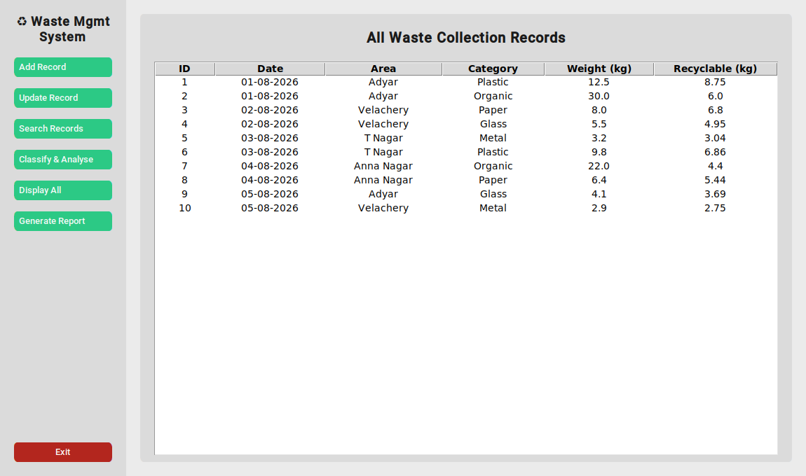
Figure 1: All waste collection records displayed in the GUI.

3.2 Classification & Analysis
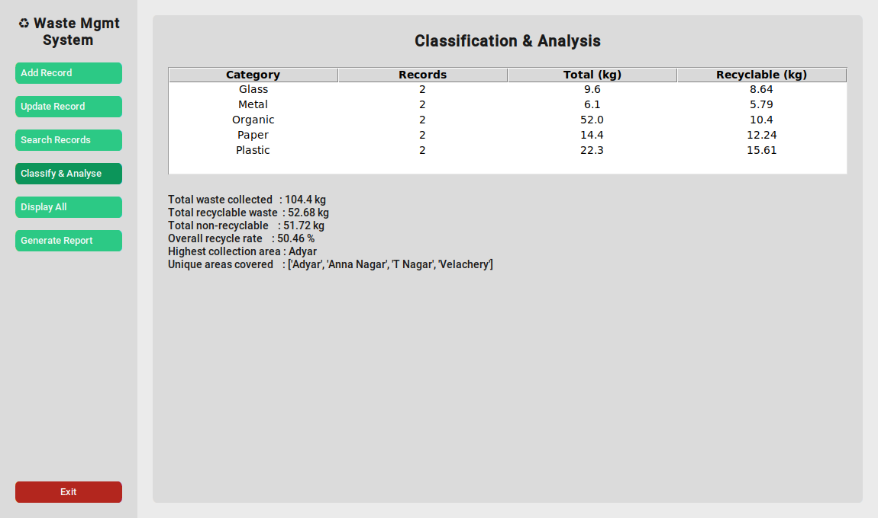
Figure 2: Category-wise classification and overall analysis.

3.3 Add Record
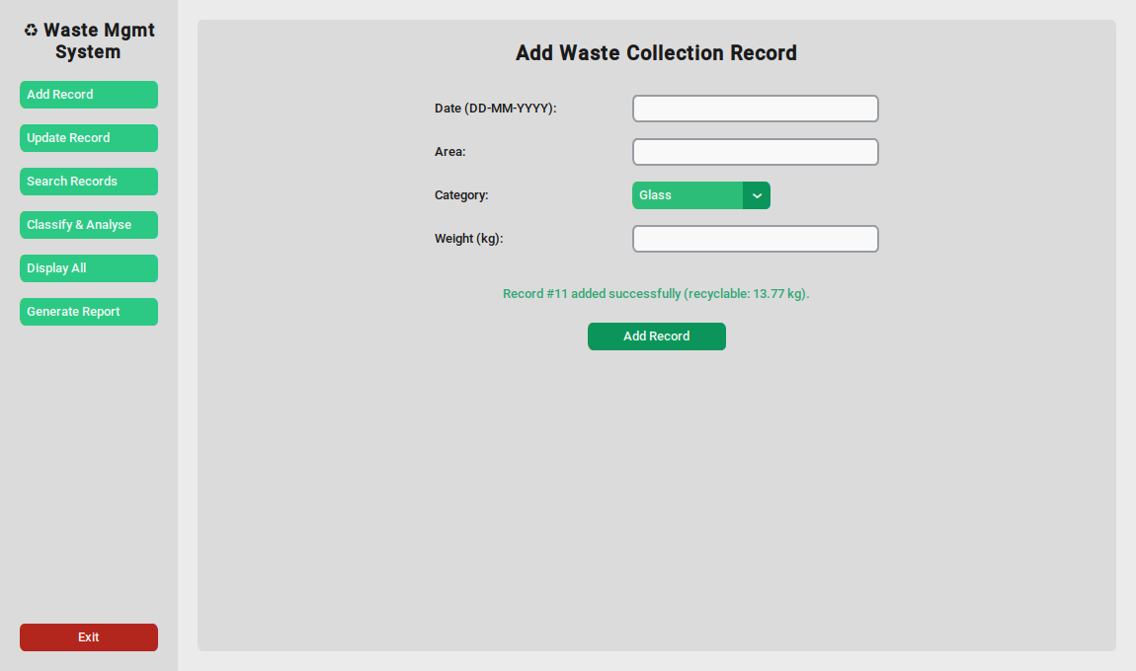
Figure 3: Adding a new waste collection record.

3.4 Search Records
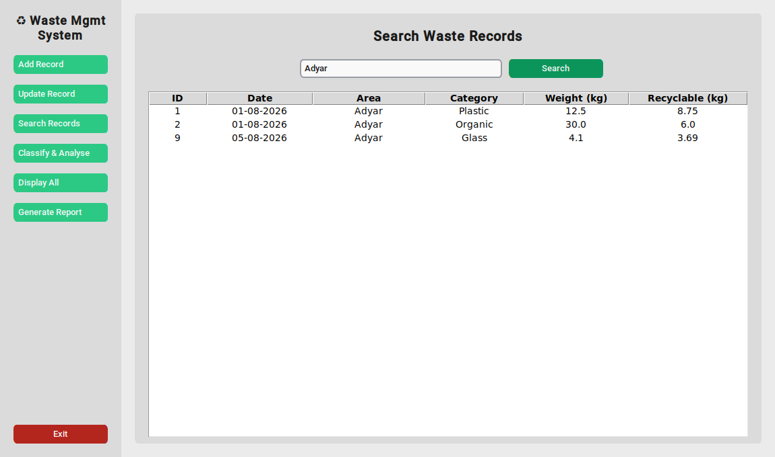
Figure 4: Searching records by area ("Adyar").

3.5 Generate Summary Report
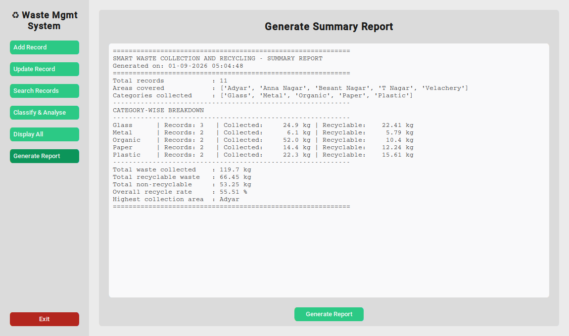
Figure 5: Generated summary report.

